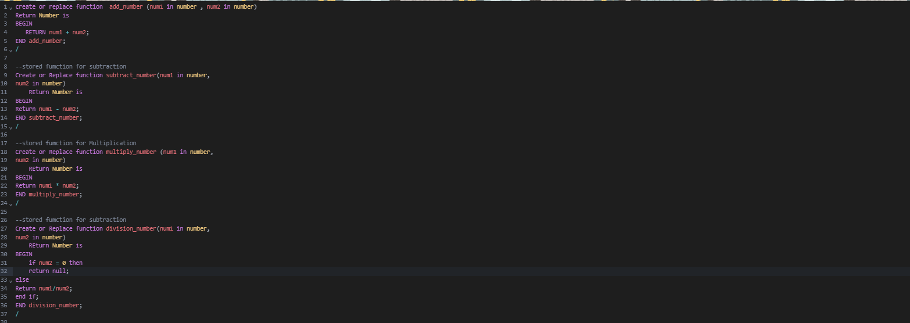

**create or replace function add_number (num1 in number , num2 in number)**

**Return Number is**

**BEGIN**

**RETURN num1 + num2;**

**END add_number;**

**/**

**--stored fumction for subtraction**

**Create or Replace function subtract_number(num1 in number,**

**num2 in number)**

**REturn Number is**

**BEGIN**

**Return num1 - num2;**

**END subtract_number;**

**/**

**--stored fumction for Multiplication**

**Create or Replace function multiply_number (num1 in number,**

**num2 in number)**

**REturn Number is**

**BEGIN**

**Return num1 * num2;**

**END multiply_number;**

**/**

**--stored fumction for subtraction**

**Create or Replace function division_number(num1 in number,**

**num2 in number)**

**REturn Number is**

**BEGIN**

**if num2 = 0 then**

**return null;**

**else**

**Return num1/num2;**

**end if;**

**END division_number;**

**/**

